Supersonic Engine Inlet Design Project

Akus Chhabra

Table of Contents

**1.0 Problem Description 1**

**2.0 Approach 1**

2.1 Supersonic Inlet Design 1

2.2 Parametric Cycle 3

**3.0 Final Design 7**

3.1 Supersonic Inlet Design 7

3.2 Parametric Cycle Analysis 11

**4.0 Conclusions 17**

**References 18**

**Appendices 19**

Appendix A: Supersonic Inlet Geometry & Parametric Cycle Analysis MATLAB Code 19

**List of Figures**

|  |  |  |
| --- | --- | --- |
| **Figure 1:** | Schematic diagram of the turbojet engine [2]. | 4 |
| **Figure 2:** | Rendition of the inlet geometry using the shock and wave angles. | 9 |
| **Figure 3:** | Optimum pressure recovery for various numbers of shocks [2]. | 10 |
| **Figure 4:** | Simulated test results of the J58 engine by NASA [7]. | 14 |
| **Figure 5:** | Turbojet efficiencies at Mach 3.0 [2]. | 16 |

**List of Tables**

|  |  |  |
| --- | --- | --- |
| **Table 1:** | Provided inlet and ramp conditions. | 1 |
| **Table 2:** | Optimal parameters for the given inlet conditions. | 7 |
| **Table 3:** | Atmospheric conditions at 60,000 ft altitude. | 12 |
| **Table 4:** | Historical data values for stagnation pressure ratios and efficiencies. | 12 |
| **Table 5:** | Resultant computed parameters for various sections of the fictional engine. | 12 |
| **Table 6:** | Performance parameters of the fictional and the J58 engine. | 15 |

# 1.0 Problem Description

The objective of this design project was to design a fictional engine that will represent the requirements of a defined mission for an aircraft traveling from New York to London. This supersonic aircraft was designed for commercial application however the main focus will be on designing and analyzing the propulsion system rather than the entirety of the aircraft. The design process was split into two sections. The first part focused on designing the supersonic inlet for a fictional engine that satisfied the ambient conditions and the desired number of shocks. Using Oswatitsch’s Principle, the optimal shock and deflection angles were calculated under the criteria that the normal mach components across each oblique shock are equal. The second section focused on conducting parametric analysis by evaluating the performance of the fictional engine and comparing it to a real supersonic engine.

**Table 1**: Provided inlet and ramp conditions.

|  |  |
| --- | --- |
| Parameter | Value |
| Number of Shocks | 3 + 1 (oblique + normal) |
| Flight Mach Number, M1 | 3.2 |
| Upstream Normal Shock, Mn | 1.3 |
| Specific Heat Ratio, γ | 1.4 |

# 2.0 Approach

### 2.1 Supersonic Inlet Design

To solve this problem, a set of equations was applied to create an iterative process for solving the conditions. The process followed the design of the shock angles, deflection angles, and mach numbers, stagnation pressure ratios, and the resultant intake pressure recovery ratio. Equation 1 provides a relation between the initial downstream mach number and the initial oblique shock angle.

$β_{1}=sin^{-1}\left(\frac{1}{M_{1}}\right)$ (1)

Equation 2 relates the deflection angle to the mach number and shock angle. By incrementing the initial shock angle, the deflection angles across each oblique shock can be calculated.

$θ=cot^{-1}\left[tanβ\left[\frac{(γ+1)M^{2}}{2(M^{2}sin^{2}β-1)}-1\right]\right]$ (2)

Equation 3 provides the upstream mach number across an oblique shock for a given mach number downstream. The mach value across the oblique shock wave is required to compute subsequent deflection angles and stagnation pressure ratios.

$M_{1}=\sqrt{\frac{(γ-1)M^{2}sin^{2}β+2}{(2γM^{2}sin^{2}β-(γ-1))(sin^{2}(β-θ))}}$ (3)

Equation 4 relates the stagnation pressure ratio across an oblique shock where the factors are the specific heat ratio of air, mach number, and shockwave angle. To compute the overall pressure recovery, the stagnation pressure ratio across each oblique shockwave is required.

$\frac{P_{o2}}{P_{o1}}={\left[\frac{(γ+1)M^{2}sin^{2}β}{(γ-1)M^{2}sin^{2}β + 2}\right]}^{\frac{γ}{γ-1}}{\left[\frac{(γ+1)}{2γM^{2}sin^{2}β-(γ-1)}\right]}^{\frac{1}{γ-1}}$ (4)

The Oswatitsch's principle relates the shockwave angles and mach numbers across each oblique shock such that when the normal components of each mach number are equal, the pressure recovery ratio across the inlet geometry is maximum.

$M_{1}sinβ_{1}=M_{2}sinβ_{2}=M_{n-1}sinβ_{n-1}$ (5)

The stagnation pressure ratio across a normal shock is represented by equation 6 where the dependent parameters are the mach number and the specific heat ratio of air.

$\frac{P_{o2}}{P_{o1}}={\left[\frac{(γ+1)M^{2}}{(γ-1)M^{2} + 2}\right]}^{\frac{γ}{γ-1}}{\left[\frac{(γ+1)}{2γM^{2}-(γ-1)}\right]}^{\frac{1}{γ-1}}$ (6)

Equation 7 relates the mach numbers before and after a normal shock. This equation depends on the specific heat ratio and the mach number before the normal shock to determine the mach number after the shock.

$M_{1}=\sqrt{\frac{(γ-1)M^{2} + 2}{2γM^{2}-(γ-1)}}$ (7)

### 2.2 Parametric Cycle

The focus of parametric cycle analysis is on analyzing the performance of a designed fictional engine. The engine must be comparable to an operational engine which was selected as the Pratt & Whitney J58 mounted on the SR-71 Blackbird. This engine was selected due to its established documentation of data that is readily available as well as the engine having entered operation for several decades until 1990 where it had achieved significant technological milestones [1], demonstrating the adequacy of the engine. In addition, it was capable of achieving altitudes above 60,000 ft. The assumption for this analysis is a non-ideal turbojet engine in order to account for losses in the different segments of the engine.

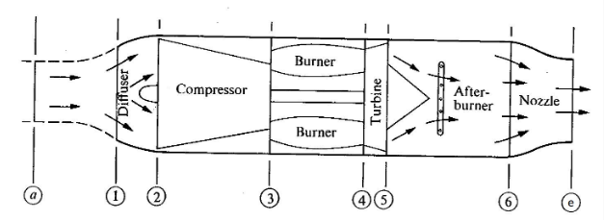

**Figure 1**: Schematic diagram of the turbojet engine [2].

The velocity at the exit and inlet of the engine are related to the mach number through equation 8. The factors of this equation include the specific heat ratio of air, universal gas constant of air, and the static temperature.

$U =M\sqrt{γRT}$ (8)

The stagnation pressure and temperature at the entrance of the compressor is determined using the isentropic relations as shown in equations 9 and 10; however the stagnation pressure requires the compression ratio of the diffuser. The compression ratio of the diffuser is the same as the pressure recovery determined in the inlet geometry analysis from the first section. Since the inlet is adiabatic and assuming reversible, the inlet can be considered isentropic. However in a real inlet, there are losses with the conversion of kinetic energy to internal energy in the diffuser [2], thus a diffuser efficiency must be accounted for.

$\frac{P_{o2}}{P_{a}}=π_{d}{\left[1+(\frac{γ+1}{2})M_{1}^{2}\right]}^{\frac{γ}{γ-1}}$ (9)

$\frac{T_{o2}}{T_{a}}=\left[1+(\frac{γ+1}{2})M_{1}^{2}\right]$ (10)

The stagnation pressure across the compressor and combustion chamber are related through equation 11. The stagnation pressure ratios for these stages are assumed based on actual engine data obtained from the J58 in order to calculate the stagnation pressure for the subsequent section of the engine.

$P_{o(n+1)}=P_{o(n)}⋅π_{}$ (11)

Equation 12 relates the stagnation temperature at the compressor exit to the compressor inlet using the compressor pressure ratio and the compressor efficiency obtained through historical data.

$\frac{T_{o3}}{T_{o2}}=1+\frac{1}{η_{c}}\left(π_{c}^{\frac{γ-1}{γ}}-1\right)$ (12)

Equation 14 determines the fuel-to-air ratio with respect to the stagnation temperatures at the inlet and exit of the combustion chamber, the efficiency of the combustion chamber, and the heating value and the pressure coefficient of air.

$f=\frac{\frac{T_{o4}}{T_{o3}} - 1}{η_{b}\left(\frac{Q_{r}}{C_{p}T_{o3}} - \frac{T_{o4}}{T_{o3}}\right)}$ (14)

To check if the nozzle is choked, equation 15 provides an inequality such that if the ratio of stagnation pressure at the turbine exit and engine exit is greater than the specific heat ratio, the nozzle is considered choked. Equation 16 can be applied given a choked nozzle scenario under the condition that the nozzle is isentropic.

$\frac{P_{o5}}{P_{e}}>{\left(\frac{γ+1}{2}\right)}^{\frac{γ}{γ-1}}$ (15)

$T_{e}=\frac{2T_{oe}}{γ+1}$ (16)

Equation 17 represents the ideal gas law used to determine the density at the exit of the engine. Equation 18 determines the inlet area of the engine where the diameter is obtained from existing data. Equations 19 to 21 are used to determine the mass flow rates of air, fuel and total mass flow rate.

${ρ=\frac{P}{RT}}_{}$ (17)

$A_{i}=\frac{πd^{2}}{4}$ (18)

$ṁ_{a}=ρ_{a}A_{i}U_{a}$ (19)

$ṁ_{f}=ṁ_{a}f$ (20)

$ṁ_{t}=ṁ_{a}+ṁ_{f}$ (21)

The exit area of the engine is shown in equation 22 where the area is dependent on air mass flow rate, fuel mass flow rate, exit pressure, exit velocity, universal gas constant of air, and exit temperature. Using the exit area, the thrust and thrust specific fuel consumption (TSFC) can be computed as indicated in equations 23 and 24.

$A_{e}=\frac{ṁ_{a}(1+f)RT_{e}}{U_{e}P_{e}}$ (22)

$T=ṁ_{t}U_{e}-ṁ_{a}U_{a}+A_{e}(P_{e}-P_{a})$ (23)

$TSFC=\frac{fṁ_{a}}{T}$ (24)

Equations 25, 26, and 27 describe the thermal, propulsive, and overall efficiency of the engine. These efficiencies provide a numerical value that indicates how well the engine performs for a set of inlet and ambient conditions.

$n_{th}=\frac{ṁ_{a}\left[(1+f)\frac{U_{e}^{2}}{2} - \frac{U_{a}^{2}}{2}\right]}{ṁ_{f}Q_{R}}$ (25)

$n_{p}=\frac{TU_{a}}{ṁ_{a}\left[(1+f)\frac{U_{e}^{2}}{2} - \frac{U_{a}^{2}}{2}\right]}$ (26)

$n_{o}=n_{th}n_{p}$ (27)

# 3.0 Final Design

### 3.1 Supersonic Inlet Design

The supersonic inlet design parameters were computed using MATLAB and displayed in table 2. A rendition of the inlet geometry is illustrated in figure 1.

**Table 2**: Optimal parameters for the given inlet conditions.

|  |  |
| --- | --- |
| Parameter | Value |
| $$M_{2}$$ | 2.566 |
| $$M_{3}$$ | 2.566 |
| $$M_{1n}$$ | 1.493 |
| $$M_{2n}$$ | 1.493 |
| $$M_{3n}$$ | 1.493 |
| $$β_{1}$$ | 27.82° |
| $$β_{2}$$ | 35.60° |
| $$β_{3}$$ | 49.98° |
| $$θ_{1}$$ | 11.90° |
| $$θ_{2}$$ | 14.45° |
| $$θ_{3}$$ | 17.22° |
| $$\frac{P_{o2}}{P_{o1}}$$ | 0.932 |
| $$\frac{P_{o3}}{P_{o2}}$$ | 0.932 |
| $$\frac{P_{o4}}{P_{o3}}$$ | 0.932 |
| $$\frac{P_{o5}}{P_{o4}}$$ | 0.979 |
| $$π_{rec}$$ | 0.793 |

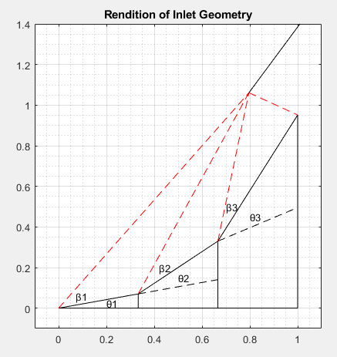

**Figure 2**: Rendition of the inlet geometry using the shock and wave angles.

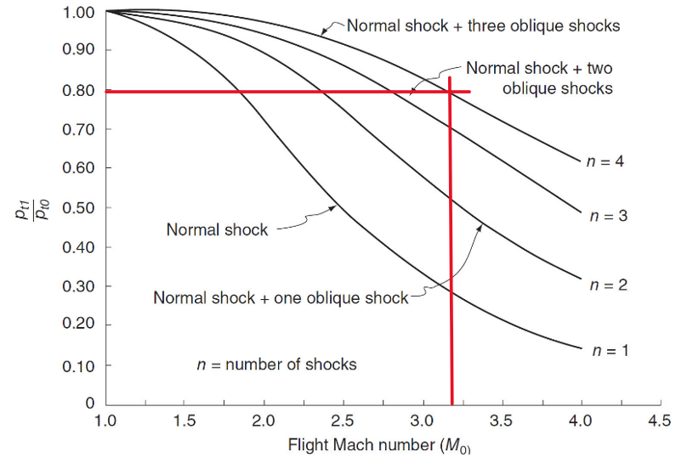

**Figure 3**: Optimum pressure recovery for various numbers of shocks [3].

Table 2 describes the computed parameters for the deflection angle, shockwave angle, stagnation pressure ratios across each shock as well as the overall pressure recovery. Figure 2 illustrates the inlet geometry with dashed red lines representing the shocks and the solid black lines representing the inlet geometry. Using Oswatitsch’s Principle, when the normal components of each mach are equal, the pressure recovery is at a maximum. To validate the recovery pressure, figure 3 provides the expected pressure recovery for an inlet mach of 3.2 and the condition of three oblique shocks and one normal shock. As the normal shock value for each oblique shock mach number is expected to be the same, the stagnation pressures must be the same across each oblique shock. From the graph, the expected pressure recovery is 0.79 whereas the computed pressure recovery for the designed geometry was 0.793. The error is approximately 0.38% thus the computed pressure recovery is acceptable.

### 3.2 Parametric Cycle Analysis

The selected aircraft engine was the Pratt & Whitney J58 mounted on the SR-71. This engine provides a similar cruise condition of mach 3.2, comparable to the given fictional design condition. The design altitude for the engine was selected to be 60000 [4] ft as previously mentioned; historically, this altitude was optimized for aircraft such as the Concorde, a supersonic passenger aircraft that was ahead of its time. The J58 engine is a turbojet with an afterburner capable of flying three times the speed of sound at altitudes of 85,000 ft [1]. Despite this high achievable altitude, the design is for a commercial supersonic jet which is expected to be significantly heavier. In addition, such high altitudes would not be feasible due to weight restrictions designated by the aircraft’s climb and cruise performance. The initial reason for such a high cruise altitude was for performing stealth missions such that it enabled the aircraft to evade enemy detection.

To perform analysis on the engine, assumptions were made to account for certain processes. The cross-sectional area of each section of the engine was assumed to be circular. The nozzle process was assumed to undergo losses in the various sections that include the inlet, diffuser, compressor, burner, and turbine. The components are not isentropic but are assumed to be adiabatic. However, estimates for the pressure losses are dependent on historical values that are obtained through research analysis of the J58 engine. If these values do not exist for the J58, similar engines were researched to determine these parameters. In addition, it was assumed that the engine behaves under a turbojet cycle rather than a ramjet despite the engine being a hybrid of both ramjet and turbojet. The exit nozzle was assumed to be perfectly expanded such that the exit pressure is equal to the ambient pressure.

For the turbine blades inlet, a material was required to be defined in order to determine the maximum temperature at the exit of the combustion chamber. Due to the extremely hot air exiting the combustion chamber, the turbine blades are at risk of failure possibly leading to a catastrophic accident. Most modern turbojets have materials that are designed for a turbine inlet temperature of 1500 to 2000 K [2], however the selected temperature of 2500 K accounts for a higher temperature threshold for the turbine blades as well as an increased efficiency as the higher the maximum allowable temperature, the more efficient the turbine [2]. In addition, the afterburner maximum temperature was designed for 2750 K as the afterburner is expected to have a higher temperature than the turbine inlet.

**Table 3**: Atmospheric conditions at 60,000 ft altitude.

|  |  |
| --- | --- |
| Parameter | Value |
| Altitude (m) | 18288 |
| Temperature (K) | 216.65 |
| Pressure (Pa) | 7232.60 |

**Table 4**: Historical data values for stagnation pressure ratios and efficiencies.

|  |  |
| --- | --- |
| Parameter | Value |
| $$π_{c}$$ | 8.8 [4] |
| $$π_{d}$$ | 0.793 |
| $$π_{b}$$ | 0.98 [2] |
| $$η_{c}$$ | 0.87 [2] |
| $$η_{b}$$ | 0.99 [2] |
| $$η_{t}$$ | 0.90 [2] |
| $$η_{n}$$ | 0.98 [2] |

Table 3 provides the assumed atmospheric conditions for the parametric cycle analysis. These values were obtained based on the altitude of 60000 ft and converted to metric units [5]. Table 4 provides the stagnation pressure ratios and efficiency factors for the unique segments of the engine that include the diffuser, compressor, combustion chamber, and turbine.

**Table 5**: Resultant computed parameters for various sections of the fictional engine.

|  |  |
| --- | --- |
| Parameter | Value |
| Inlet Velocity, Ua (m/s) | 944.14 |
| Inlet Area, Ai (m2) | 1.00 |
| To2 (K) | 660.35 |
| Po2 (kPa) | 283.39 |
| To3 (K) | 1314.21 |
| Po3 (kPa) | 2493.80 |
| To4 (K) | 2500.00 |
| Po4 (kPa) | 2443.92 |
| To5 (K) | 2750.00 |
| Po5 (kPa) | 763.49 |
| To6 (K) | 2750.00 |
| Po6 (kPa) | 748.22 |
| To7 (K) | 2750.00 |
| Po7 (kPa) | 748.22 |
| Exit Velocity, Ue (m/s) | 3070.65 |
| Fuel-to-air Ratio | 0.0276 |
| Air Mass Flow Rate, ṁa (kg/s) | 109.96 |
| Fuel Mass Flow Rate, ṁf (kg/s) | 3.03 |
| Exit Area, Ae (m2) | 3.35 |

Table 5 provides the intermediate results used to compute the performance parameters of the fictional engine. The stagnation temperature and pressure at the inlet of the compressor were determined using isentropic relations such that the pressure recovery of the inlet was incorporated from the supersonic inlet geometry design. The computed values must be smaller compared to the remaining segments of the engine that include the compressor, combustion chamber, and turbine. At the entrance to the combustion chamber, the stagnation temperature and pressure are higher than the compressor inlet due to its purpose of increasing the air pressure, resulting in an increase in temperature. In addition, the losses across each segment were accounted for through efficiency factors and compression ratios. Similar to the compressor, the combustion chamber stagnation temperature and pressure were determined using historical data for the combustion chamber stagnation pressure ratio and the combustion chamber efficiency. Likewise, the turbine efficiency and stagnation pressure ratio were obtained from historical sources as well.

In order to produce thrust, the exit velocity must exceed the inlet velocity. Since the exit velocity of 3,070 m/s was greater than the inlet velocity of 944 m/s, the engine must be able to produce thrust. The air mass flow rate of the engine was determined using the density of air at 60,000 ft, the inlet area, and the inlet velocity. The computed air mass flow rate of 110 kg/s was acceptable as it is within proximity to the J58 air mass flow rate of 200 kg/s [5]. The fuel-to-air ratio was calculated using the stagnation temperature ratio between the turbine inlet and combustion chamber inlet in addition to the heating value of kerosene, 45 MJ [6]. The resultant value was 0.0276 whereas the published NASA value for mach 2.80 at 19.8 km altitude was 0.033 [7]. Despite the freestream mach number not matching the provided mach data, the fuel-to-iron ratio is expected to decrease with increasing mach numbers as shown in figure 4.

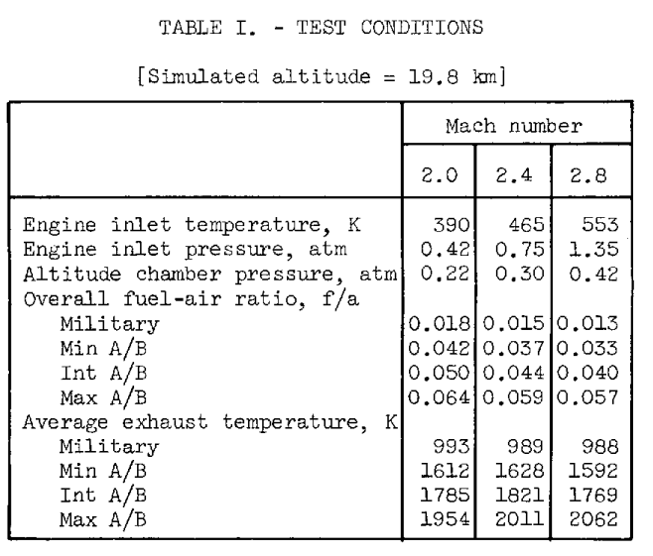

**Figure 4**: Simulated test results of the J58 engine by NASA [7].

An essential step in determining the performance parameters was checking for the choked nozzle condition. The condition for checking this condition was indicated in equation 15, outlining an inequality such that when the ratio of the pressures after the turbine and exit are greater than the specific heat ratio expression, the nozzle is choked.

**Table 6**: Performance parameters of the fictional and the J58 engine.

|  |  |  |
| --- | --- | --- |
| Performance Parameter | Fictional Engine | J58 Engine |
| Thrust (kN) | 243.14 | 150.0 [8] |
| TSFC (kg/s/kN) | 0.01246 | 0.05380 [8] |
| Thermal Efficiency (%) | 344.56 | - |
| Propulsive Efficiency (%) | 47.46 | - |
| Overall Efficiency (%) | 163.53 | - |

Table 5 illustrates the computed performance parameters for both the fictional and Pratt & Whitney J58 engine. The fictional engine produces significantly more thrust than the J58 engine and has a lower thrust specific fuel consumption (TSFC) which is considered ideal. In reality, this is not achievable as having high thrust and high efficiency are not possible without a tradeoff. In general, the thrust decreases with an increase in TSFC and vice versa. With a larger TSFC, the fuel consumption per hour increases, an undesirable product of the engine.

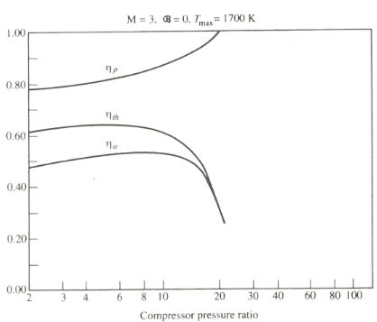

**Figure 5**: Turbojet efficiencies at Mach 3.0 [2].

Figure 5 illustrated the expected efficiencies for the propulsive, thermal and overall efficiencies. This figure provides a reference temperature and mach for comparing the fictional engine efficiencies. At the design compressor ratio of 8.8, the propulsive, thermal and overall efficiencies are expected to be 85%, 61%, and 52% respectively. Although the efficiencies are representative for mach 3.0 and a maximum temperature of 1700 K, these efficiencies are significantly different from the computed efficiencies shown in table 6. The thermal efficiency is unrealistic as the efficiency exceeds 100%. A possible reason for this large efficiency is the large exhaust velocities. The exhaust velocity was calculated to be 3070 m/s whereas the inlet velocity was 944 m/s. Since the magnitude of the velocities are not the same, the resultant thermal efficiency is therefore greater than one. In addition, the increasing mass flow rates results in an increase in the magnitude of the thermal efficiency. It is expected that the propulsive efficiency must be greater than the thermal efficiency for any compressor pressure ratio. Given that the overall efficiency is dependent on thermal and propulsive efficiency, the computed efficiencies are not realistic.

# 4.0 Conclusions

To summarize, this project investigated the design process of a fictional engine for commercial supersonic flight. The first part involved the designing of a supersonic inlet geometry for a given set of input conditions. Using Oswatitsch’s principle, when the normal components of each mach number across each shock were equal, the maximum pressure recovery was attained and was computed to be 0.793. The second design objective involved parametric analysis where the performance parameters of the fictional engine were designed based on research and historical data. This data included stagnation pressure ratios and efficiencies across various stages of a turbojet. In addition, several assumptions were made in order to determine the performance parameters of the engine. The fictional engine's performance was compared against the J58 engine mounted on the SR-71. The fictional engine provided a higher thrust of 243.14 kN and lower TSFC value of 0.01246 kg/kN/s whereas the J58 had a thrust of 150 kN and a TSFC of 0.05380 kg/kN/s. Despite the designed fictional engine providing realistic values for the stagnation temperatures, pressures, mass flow rates, fuel-to-air ratio, and thrust, it did not provide appropriate thermal, propulsive and overall efficiencies. In a real supersonic application, the fuel consumption is significantly higher than that of subsonic commercial engines. The J58 was designed with the mission of high altitude stealth flight for the SR-71, requiring high fuel consumption to achieve such high cruise speeds and altitudes. Furthermore the inclusion of an afterburner significantly increases the amount of fuel burned as fuel is burned in the exhaust inefficiently. Ergo a higher fuel consumption is to be expected.

For future designs, the number of assumptions made will require revision as not all are applicable in the designing of a real engine, specifically with their contribution to the error in certain parameters. For instance, the exit area was computed to be 3.35 m2 which was larger than expected. The area was estimated using the exit density calculated from the exit pressure, exit temperature, exit velocity, air mass flow rate, and fuel-to-air ratio. With all of these parameters being factors of the exit area, it is important to determine which assumptions are valid for each individual segment of the turbojet.

# References

[1] National Air and Space Museum, “Lockheed SR-71 Blackbird,” National Air and Space Museum, 2012. https://www.si.edu/object/lockheed-sr-71-blackbird%3Anasm_A19920072000

[2] E. Karatas, “Turbojets Parametric Cycle Analysis,” Toronto Metropolitan University, Toronto, 2024.

[3] E. Karatas, “Review of Thermodynamics and Fluid Mechanics,” Toronto Metropolitan University, Toronto, 2024.

[4] “Concorde,” Museum of Flight. https://www.museumofflight.org/exhibits-and-events/aircraft/concorde#:~:text=Capable%20of%20speeds%20over%20two‌

[5] “Pratt Whitney J-58 Aircraft Engine Pictures, Information and Specifications,” www.airpowerworld.info. http://www.airpowerworld.info/aircraft-engine-manufacturers/pratt-whitney-j-58.htm (accessed Mar. 25, 2024).‌

[6] Engineering ToolBox, “U.S. Standard Atmosphere,” Engineeringtoolbox.com, 2003. https://www.engineeringtoolbox.com/standard-atmosphere-d_604.html‌

[7] Engineering Toolbox, “Fuels - Higher and Lower Calorific Values,” Engineeringtoolbox.com, 2019. https://www.engineeringtoolbox.com/fuels-higher-calorific-values-d_169.html‌

[8] “NASA TM X-71571 MEMORANDUM.” Accessed Mar. 24, 2024. https://ntrs.nasa.gov/api/citations/19740021102/downloads/19740021102.pdf‌

# Appendices

### Appendix A: Supersonic Inlet Geometry & Parametric Cycle Analysis MATLAB Code

clear; clc; close all;

% Akus Chhabra

% 500970974

%% Parameter Definitions

num_shock = 4; % 3 oblique shocks + 1 normal shock

M1 = 3.2; % Downstream Mach

M4 = 1.3; % Upstream Mach

gamma = 1.4; % Specific Heat Ratio

%% Inlet Design

inc = 0.0001;

Mn_norm = 0;

beta = asind(1/M1);

Stag_ratio4 = ((((gamma+1)*M4^2)/((gamma-1)*M4^2+2))^((gamma)/(gamma-1))) * (((gamma+1)/(2*gamma*M4^2-(gamma-1)))^(1/(gamma-1)));

M5 = ((gamma-1)*M4^2+2)/(2*gamma*M4^2-(gamma-1));

while Mn_norm ~= M4

[theta, Stag_ratio, M2] = Oblique(M1, gamma, beta);

beta2 = asind(M1*sind(beta)/M2);

[theta2, Stag_ratio2, M3] = Oblique(M2, gamma, beta2);

beta3 = asind(M2*sind(beta2)/M3);

[theta3, Stag_ratio3, Mn_norm] = Oblique(M3, gamma, beta3);

if Mn_norm > M4

beta = beta + inc;

else

break

end

end

P_rec = Stag_ratio*Stag_ratio2*Stag_ratio3*Stag_ratio4;

%% Print Results from Part 1

fprintf('\n\nM1 = %.3f', M1)

fprintf('\nM2 = %.3f', M2)

fprintf('\nM3 = %.3f', M3)

fprintf('\nM1n = %.3f', M1*sind(beta))

fprintf('\nM2n = %.3f', M2*sind(beta2))

fprintf('\nM3n = %.3f', M3*sind(beta3))

fprintf('\nBeta1 = %.2f deg', beta)

fprintf('\nBeta2 = %.2f deg', beta2)

fprintf('\nBeta3 = %.2f deg', beta3)

fprintf('\nTheta1 = %.2f deg', theta)

fprintf('\nTheta2 = %.2f deg', theta2)

fprintf('\nTheta3 = %.2f deg', theta3)

fprintf('\nPo2/Po1 = %.3f', Stag_ratio)

fprintf('\nPo3/Po2 = %.3f', Stag_ratio2)

fprintf('\nPo4/Po3 = %.3f', Stag_ratio3)

fprintf('\nPo5/Po4 = %.3f', Stag_ratio4)

fprintf('\nPressure Recovery = %.3f\n\n', P_rec)

%% Rendition of Inlet Geometry

theta_list = [0 theta theta2+theta theta3+theta2+theta];

beta_list = [0 beta beta2 beta3];

x = [0 0.333 0.666 1]';

y = zeros(size(x,2),1);

for i = 1:length(x)

y(i) = x(i)*tand(theta_list(i));

end

y_flat = [y(1) y(1) y(1) y(1)];

figure(1)

plot(x,y,'color', 'black')

hold on

plot([x(2) x(3)],[y(2) x(3)*tand(theta_list(2))],'color', 'black', 'linestyle', '--')

plot([x(3) x(4)],[y(3) x(4)*tand(theta_list(3))],'color', 'black', 'linestyle', '--')

plot(x,y_flat,'color', 'black')

plot([x(2) x(2)],[y(1) y(2)],'color', 'black')

plot([x(3) x(3)],[y(1) y(3)],'color', 'black')

plot([x(4) x(4)],[y(1) y(4)],'color', 'black')

title('Rendition of Inlet Geometry')

delX = 0.13; % Change Cowl Edge location

m_shock = -1/((y(4)-y(3))/(x(4)-x(3)));

b = y(4) - m_shock*x(4);

plot([(x(3)+delX) x(4)], [m_shock*(x(3)+delX)+b m_shock*x(4)+b],'color', 'red', 'linestyle', '--'); % Normal Shock

plot([x(3)+delX x(4)+delX],[m_shock*(x(3)+delX)+b ((-1/m_shock)*x(4)+b)*sind(theta_list(4))^2],'color', 'black'); % Cowl Edge

plot([x(1) (x(3)+delX)],[y(1) m_shock*(x(3)+delX)+b],'color', 'red', 'linestyle', '--') % Oblique Shock 1

plot([x(2) (x(3)+delX)],[y(2) m_shock*(x(3)+delX)+b],'color', 'red', 'linestyle', '--') % Oblique Shock 2

plot([x(3) (x(3)+delX)],[y(3) m_shock*(x(3)+delX)+b],'color', 'red', 'linestyle', '--') % Oblique Shock 3

hold off

ylim([-0.1 1.4])

xlim([-0.1 1.1])

grid on

grid minor

text(x(1)+0.07,y(1)+0.06,'β1')

text(x(1)+0.2,y(1)+0.025,'θ1')

text(x(1)+0.42,y(1)+0.2,'β2')

text(x(1)+0.5,y(1)+0.15,'θ2')

text(x(1)+0.7,y(1)+0.5,'β3')

text(x(1)+0.8,y(1)+0.45,'θ3')

%% Parametric Cycle Analysis

% Parameters

alt = 60000; % ft

R = 287; % J/kg/K

Cp = gamma*R/(gamma-1); % J/kg/K

inlet_diameter = 1.448; % m

inlet_area = pi*(inlet_diameter^2)/4; % m^2

inlet_area = 1; % m^2

Qr = 46200*10^3; % J/kg

Ta = -56.5 + 273.15; % K

Pa = 7232.6004; % N/m^2

rho_a = 0.11647; % kg/m^3

% Assumed Parameters

pi_c = 8.8;

pi_d = P_rec;

pi_b = 0.98;

n_c = 0.87; % Compressor

n_b = 0.99; % Combustor

n_t = 0.90; % Turbine

n_n = 0.98; % Nozzle

Ua = M1*sqrt(gamma*R*Ta);

Po2 = pi_d*Pa*(1+((gamma-1)/2)*(M1^2))^(gamma/(gamma-1));

To2 = Ta*(1+((gamma-1)/2)*(M1^2));

Po3 = Po2*pi_c;

To3 = To2*(1+(1/n_c)*((pi_c^((gamma-1)/gamma))-1));

Po4 = Po3*pi_b;

To4 = 2500; % Defined manually

f = ((To4/To3-1)/((n_b*Qr/Cp/To3 - To4/To3)));

To5 = To4-((To3-To2)/(1+f));

Po5 = Po4*(1+(1/n_t)*(To5/To4-1))^(gamma/(gamma-1));

Po6 = Po5*pi_b;

To6 = 2750; % Defined manually

Po7 = Po6;

To7 = To6;

T7 = To7/(1+((gamma+1)/2)*M1^2);

Pe = Pa;

if Po5/Pe > ((gamma+1)/2)^(gamma/(gamma-1))

fprintf('Flow is Choked.')

Toe = To7;

Te = 2*Toe/(gamma+1);

Pe = Pa;

Me = M1;

Ue = Me*sqrt(gamma*R*Te);

rho_e = Pe/R/Te;

end

ma_dot = rho_a*inlet_area*Ua;

mf_dot = ma_dot*f;

mt_dot = ma_dot + mf_dot;

exit_area = ma_dot*(1+f)*R*Te/Ue/Pe;

T = (mt_dot*Ue) - ma_dot*Ua + exit_area*(Pe-Pa);

TSFC = f*ma_dot/T;

n_th = ma_dot*((1+f)*((Ue^2/2)-(Ua^2/2)))/(mf_dot*Qr); %n_th = ((1+f)*(Ue^2/2) - Ua^2/2)/(f*Qr)*100;

n_p = (T*Ua)/(ma_dot*((1+f)*Ue^2/2 - Ua^2/2));

n_o = n_th*n_p;

%% Print Results from Part 2

fprintf('\n\nUa = %.2f m/s', Ua)

fprintf('\nInlet Area = %.2f', inlet_area)

fprintf('\nTo2 = %.2f K', To2)

fprintf('\nPo2 = %.2f kPa', Po2/1000)

fprintf('\nTo3 = %.2f K', To3)

fprintf('\nPo3 = %.2f kPa', Po3/1000)

fprintf('\nTo4 = %.2f K', To4)

fprintf('\nPo4 = %.2f kPa', Po4/1000)

fprintf('\nTo5 = %.2f K', To5)

fprintf('\nPo5 = %.2f kPa', Po5/1000)

fprintf('\nTo6 = %.2f K', To6)

fprintf('\nPo6 = %.2f kPa', Po6/1000)

fprintf('\nTo7 = %.2f K', To7)

fprintf('\nPo7 = %.2f kPa', Po7/1000)

fprintf('\nUe = %.2f m/s', Ue)

fprintf('\nAir mass flow rate = %.2f kg/s', ma_dot)

fprintf('\nFuel mass flow rate = %.2f kg/s', mf_dot)

fprintf('\nExit Area = %.2f m^2', exit_area)

fprintf('\n\nThrust = %.2f kN', T/1000)

fprintf('\nTSFC = %.5f kg/(kN*s)', TSFC*1000)

fprintf('\nThermal Efficiency = %.2f%', n_th*100)

fprintf('\nPropulsion Efficiency = %.2f%', n_p*100)

fprintf('\nOverall Efficiency = %.2f%\n\n', n_o*100)

%% Function Definition

function [theta, Stag_ratio, M1] = Oblique(M, gamma, beta)

A = (((gamma+1)*M^2*(sind(beta))^2)/((gamma-1)*M^2*(sind(beta))^2+2))^(gamma/(gamma-1));

B = (((gamma+1))/(2*gamma*M^2*(sind(beta))^2-(gamma-1)))^(1/(gamma-1));

Stag_ratio = A*B;

C = (gamma+1)*M^2;

D = 2*(M^2*(sind(beta))^2-1);

theta = acotd(tand(beta)*(C/D-1));

M1_num = (gamma-1)*M^2*(sind(beta))^2 + 2;

M1_denom = (2*gamma*M^2*(sind(beta))^2-(gamma-1)) * (sind(beta-theta))^2;

M1 = sqrt(M1_num/M1_denom);

end